**Gordo Bot**



*Final Report*

Team 6

Zachary Laguna

Raney Ankele

Reid Morse

Cody Nguyen

Thomas “Jake” Rod

Nicholas Soliman

Department of Computer Science

Texas A&M University

05/04/22

Table of Contents

Executive summary 3

Project background 4

Needs statement 4

Goal and objectives 4

Design constraints and feasibility 4

Literature and technical survey 5

Evaluation of alternative solutions 7

Final design 8

System description 8

Complete module-wise specifications 9

Approach for design validation 13

Implementation notes 14

Database and Docker Container 14

JSON Objects 15

Raspberry Pi Software 15

Angular Setup 18

Experimental results 19

User’s Manuals 22

Course debriefing 28

Budgets 30

References 32

# Executive summary

The Gordo Bot is a tool designed to simplify a user’s experience with the process of cooking or any other form of meal preparation. Since a large portion of individuals have a tendency to resort to eating fast food or processed foods when time is too valuable to waste cooking. Gordo Bot helps incentivize users to cook their meals not only in a timely manner but also with an increase in simplicity. This product is designed to increase the overall healthiness of customers by decreasing the amount of time and difficulty of the cooking process, thus encouraging individuals to create healthy meals in the comfort of their own kitchen. One of the main goals of this project is to have a device that the user can interface with to search for recipes that best suit their preferences. This device will also have the ability to understand the necessary ingredients for the recipe/recipes and properly dispense portions accurately. This feature will allow users to simply select a meal they would like to make and then immediately have all of the ingredients in the correct portions laid out in front of them. Then users can follow an on-screen guide on how to go about creating their dish. With just a few taps on Gordo Bot’s on-screen display the user will have all the information they need to begin the cooking process.

While the concept of the Gordo Bot may seem simplistic, the steps to actually design and implement this product are quite thorough. The four main components of the Gordo Bot are the user interface display, Raspberry Pi, measuring device, and motorized storage containers for the spices. The user interface is used to select a recipe from a database and pass that information to the device. This information is what will be used to determine the required seasoning as well as the quantity. The Raspberry pi’s purpose is to control any moving parts via GPIO. While the measuring device is used to obtain exact measurements of corresponding ingredients. Finally, the storage containers will store spices and have the ability to rotate to the spice selected by the user. All these components are further explained in the “Design Specifications” in Section 4.2. But the team is well suited for all the challenges that lie ahead. We have a diverse mix of individuals with various specialties. Each member will primarily be focusing on different components of the Gordo Bot but still managing to work as a team to ensure proper synchronization between all of the various components of this project. Our constant communication will ensure that all members are aware of the current status of the project as well as the necessary tasks to be completed in a hierarchical manner of prioritization.

The final product will be a medium-sized kitchen appliance with a simple user interface. The clean and minimalistic design hopefully encourages the user to not be overwhelmed by its various features. The user interface will be easy to understand and navigate allowing the experience to be smooth and without confusion. The main appeal for a customer to purchase this product is to simplify their everyday life by saving time that the user may need. The Gordo Bot will have the ability to technically prepare food faster than any delivery service or by purchasing from a restaurant. Not only will this product save time for the user but it will also inevitably save money since expenses are generally more expensive from a restaurant as opposed to a local grocery store. The Gordo Bot is targeted at individuals who would like to improve their diet as well as free up time and money wasted from purchasing meals from restaurants regularly. Many statistics will be explained thoroughly to justify this statement as well as the logic behind the Gordo Bot itself. The following sections will provide detailed information regarding the need for this project, the goals and objectives, the design, and how the development team will go about creating this product.

# Project background

Cooking at home has become more appealing these days as covid-19 frightens the populous and healthy, home-cooked meals become an appealing alternative to greasy take-out food. According to a new study by Hunter, a consumer market research firm, 71% of people in the U.S. say that they will continue to cook at home after the end of the pandemic. However, consumer culture has promoted that ordering takeout or using Uber Eats and DoorDash are more efficient methods of procuring sustenance, thus producing sub-optimal cuisine from our stay-at-home chefs. [1]

## Needs statement

The study goes on to find that about 25% of these cooks are learning more and building confidence in the kitchen, and almost another 25% are just as confident as they have always been. The latter could be some that were always confident or some that were never confident, implying that some of these cooks could still struggle with some of the basic steps when cooking at home. Following a recipe with precise and intricate steps can be difficult for new cooks when dishes increase in complexity, and measuring ingredients takes time and practice. What can be done to assist amateur chefs in the kitchen who are intimidated by long recipes and struggle with measuring ingredients? [1]

## Goal and objectives

This project aims to assist amateur cooks with prepping and preparing recipes so that the cook can focus on the actual cooking rather than the gathering, measuring, and mixing of ingredients. Tedious parts of cooking should be automated. With this in mind, there are several objectives planned to achieve this goal.

At the minimum, our project should be able to pull and display recipes to the user through some interface, whether that is with a screen on the device or a web app. We would start with hand-selected recipes. This should be handled by a Raspberry Pi on the device, communicating with some web-server/database or locally hosting this information.

The robot should be able to understand a recipe’s requirements and dispense the ingredients with correct measurements into a container. The ingredient selection will be handled by some servo-controlled by the Raspberry Pi, and the measurement of ingredients will be handled by sensors (either by weight and/or flow rate). The robot can be expected to perform this task in a kitchen at a reasonable pace (faster than manually measuring and mixing ingredients).

Ideally, recipes could be scraped from the internet (assuming the recipes are publicly available to use) and stored in a cloud database. These recipes would be parsed and measurements would be formatted for the Raspberry Pi to understand and use as instructions for the various sensors on the device. A search option could be implemented to easily find different recipes. Options could be chosen using voice commands.

There are objectives that are not a top priority such as implementing simple accounts that would allow users to save recipes and provide them with recommendations or keeping track of how much of each ingredient a user has and reminding them to get some more.

## Design constraints and feasibility

The constraint to take into consideration is space. Counter space in a kitchen is limited, so the device should not be larger than the average kitchen appliance. The general goal of the project is achievable with a servo, Raspberry Pi, and sensors, however, the efficiency and accuracy of these devices in our particular application are unknown. Each device will have a range of accuracy that needs to be accounted for. Recipes that require precise/small measurements may not be achievable without higher (expensive) sensors or fine-tuning. Experimenting will need to be done to understand the limitations of the sensors.

Another limitation of the hardware will be the speed to choose, measuring, and dispensing the ingredients. The weight of all the ingredients will put some strain on the servo, so a servo must be chosen within the budget that can handle the weight of the ingredients.

Powering all the devices must be considered as well, the GPIO of a Raspberry Pi may not be able to handle all the interfacing of the devices, so an external power solution should be considered.

The total cost of the device is not expected outside of the budget, but the time frame this project is produced will limit how much can be done with the device. The minimum objective stated previously should easily be achieved, but the amount of time remaining will dictate the “stretch goals” of the project.

## Literature and technical survey

The main goal of our product is to assist amateur, time-crunched, or simply tired at-home chefs. It’s hard to automate telling when a dish has turned just the perfect color, but it is possible to assist many people to speed up the process by doing some common tasks. A lot of prep time and confusion comes from the measurement ingredients. This is the focus of our product. There are many common measuring tools available, but our product aims to combine and automate them.

1. Common Sets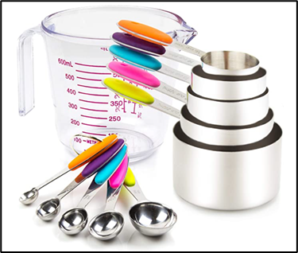

The most common types of measuring tools used are those in sets such as shown to the [left](https://www.amazon.com/Measuring-Stainless-Including-5-Piece-Transparent/dp/B07H2TKNNV/ref=sr_1_2?crid=KVTTFTJUZB3V&keywords=kitchen+measuring&qid=1645377639&sprefix=kitchen+measuring%2Caps%2C102&sr=8-2). They are common because they are simple, affordable, and have a wide application. However, they are often confusing and troublesome to use due to the many pieces involved. They are a pain to clean. They all look the same, making it easy to mistake one for another. The many pieces can take up a lot of space in kitchen cabinets or drawers. Lastly, their small size brings the possibility of losing one or two pieces of a set.

1. Adjustable

To address the issue of easily lost pieces, there has been an invention of adjustable measuring devices. These have a movable divider or plunger which can make a single device able to encompass a similar function as the multiple cup set. These adjustable devices are especially useful for measuring spices, which often require very small portions and each spice typically needs differing amounts.

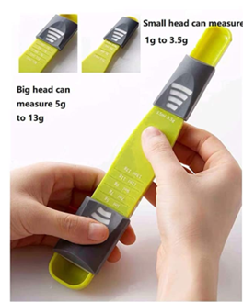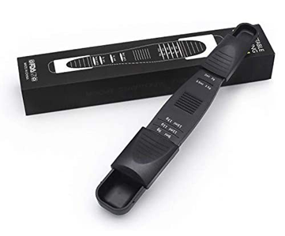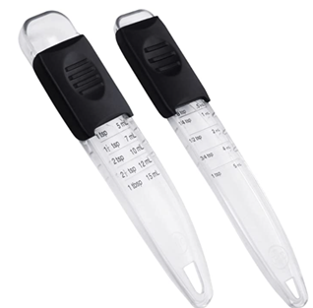

The above are several examples of these kinds of adjustable spice devices ([link 1](https://www.amazon.com/PUZERM-Adjustable-Measuring-Semi-Liquid-Ingredients/dp/B08SHBYJZH/ref=sr_1_46?crid=1SSPUQW0IVH9&keywords=kitchen%2Bmeasuring%2Badjustable&qid=1645377706&sprefix=kitchen%2Bmeasuring%2Badjustable%2Caps%2C87&sr=8-46&th=1), [link 2](https://www.amazon.com/Generic-Adjustable-Measuring-Spoon-Black/dp/B08RDYGLS8/ref=sr_1_47?crid=1SSPUQW0IVH9&keywords=kitchen+measuring+adjustable&qid=1645377706&sprefix=kitchen+measuring+adjustable%2Caps%2C87&sr=8-47), [link 3](https://www.amazon.com/Professional-Adjustable-Measuring-Ingredient-Dishwasher/dp/B09P4K7PR3/ref=sr_1_45?crid=1SSPUQW0IVH9&keywords=kitchen+measuring+adjustable&qid=1645377706&sprefix=kitchen+measuring+adjustable%2Caps%2C87&sr=8-45)). The first two are measured in grams, while the last set is for tablespoons and teaspoons. This discrepancy in units is a problem across all measuring tools, especially for an amateur who may find a recipe online they’d like to try but have conflicts with measurement metrics. With that said, these do minimize space taken up and have fewer pieces to keep track of, but can be more complicated to clean in the grooves of the moving parts. There are also adjustable types made for liquids or larger amounts of dry ingredients, to which the same problems apply, such as shown in the [first picture below](https://www.amazon.com/OXO-Good-Grips-Adjustable-Measuring/dp/B00A2KDAIW/ref=pd_day0fbt_img_2/136-8989450-3561722?pd_rd_w=Yi6AZ&pf_rd_p=bcb8482a-3db5-4b0b-9f15-b86e24acdb00&pf_rd_r=8BPNXFT2KT5W1RV9NGER&pd_rd_r=b03cd237-d979-471a-aa94-414ba4d017b5&pd_rd_wg=GXUmc&pd_rd_i=B00A2KDAIW&th=1). Finally, there are several products that attempt to use creative methods to accept many units of measurement, such as in the [second picture](https://www.amazon.com/Kare-Kind-Adjustable-Measuring-Spoons/dp/B08J4B94Y5/ref=sr_1_38?crid=1SSPUQW0IVH9&keywords=kitchen+measuring+adjustable&qid=1645377706&sprefix=kitchen+measuring+adjustable%2Caps%2C87&sr=8-38), but often end up looking odd.

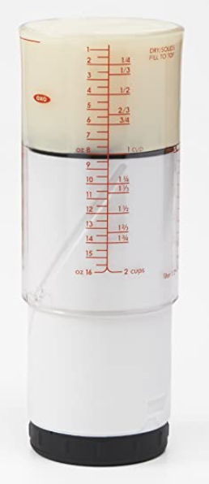 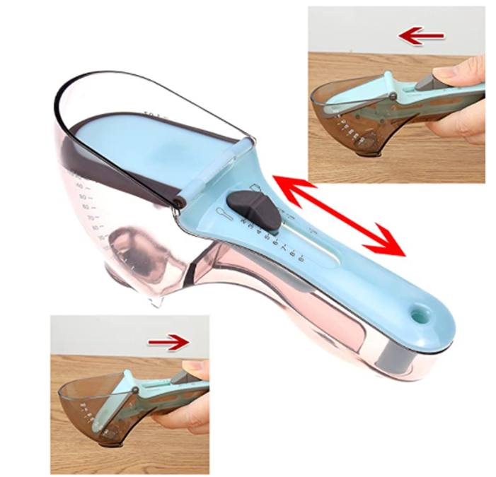

1. Select-A-Spice

The most notable competing product available on the current market is the [Select-A-Spice Auto-Measure Carousel](https://www.amazon.com/dp/B0000VLQTS/ref=as_li_ss_tl?linkCode=ll1&tag=fwautospicedispenseramazonmgandara0120-20&linkId=6283c7feef37ff826604feb0dc2c689d&language=en_US&th=1). It is designed to function as a spice rack made to neatly organize a large variety of small bottles but also doubles as an easy-to-use dispensing tool.

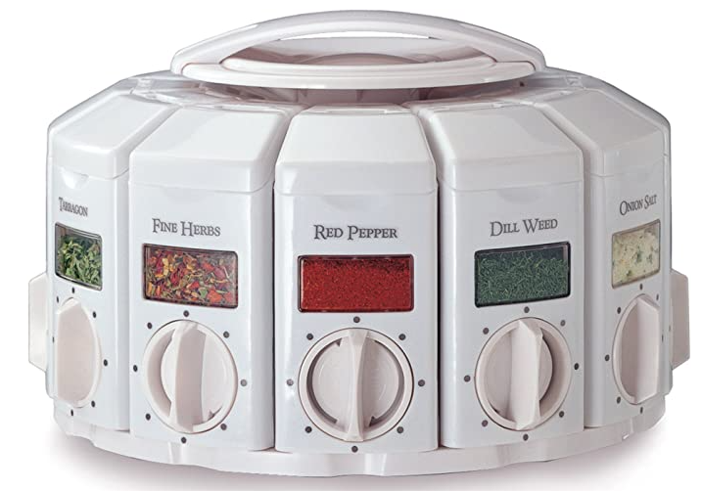 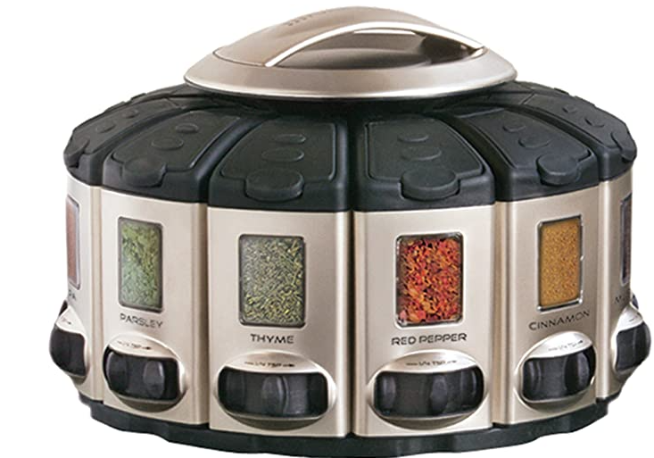

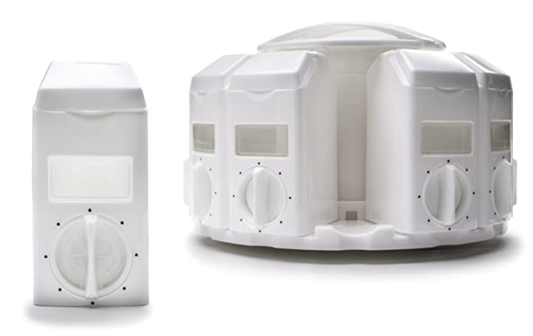 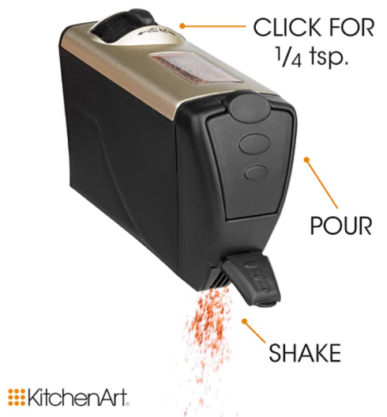

The Select-A-Spice comes in two styles that function the same: white with a dial and satin with a slider. The canisters are removable from the carousel. The spices can be filled in the canisters, then an amount can be selected, allowing the spice canister to shake out this desired amount. There are labels that can be placed to differentiate spices. Multiple carousels can be stacked.

This product does very well in achieving the aim for our product, but it is limited to spices only. Ideally, we would be able to measure any type of substance in any measurement unit. Measurement units have a common conflict between metric and custom U.S. units. There are different measurements for liquids and solids. Finally, there are some measurements that must use a scale. We aim for the ability to measure fluid ounces, liters, milliliters, cups, tablespoons, teaspoons, grams, pounds, mass ounces, etc. for all cooking needs.

1. Miscellaneous

While we are creating this device, it would not be so difficult to add a couple of other low-effort but helpful devices. This may include things like a thermometer or timer, often used in recipes.

## Evaluation of alternative solutions

To come up with our final design solution, we first needed to draft up a wide variety of solutions and select which would be best for our needs and goals. Some of the other solutions that we initially came up with were the following:

* Linear design

One of our very first designs was similar to what we are currently doing with the Gordo

Bot. However, in this design, the spices were not held in a spherical storage chamber

that rotated. The spices were stored in containers in a linear fashion. While this product

may have been easier to design and implement, it would have taken up significantly

more kitchen space, making it less ideal than our current design. So we figured that

a few extra steps to help build a realistic solution for the customer is what would be

ideal.

* Kitchen All-In-One

This design was an extension of the Gordo Bot in which we got slightly carried away

with various features. The design consisted of not only a seasonings/spices

automated storage unit but also things like a thermometer and other sensors used for

cooking to be attached to the main body of the Gordo Bot. However, they were all

wireless tools that could be carried anywhere in the kitchen but they still could

communicate with the main device. While this version of the Gordo Bot seemed quite

impressive and would meet more needs than our current Gordo Bot, it came with a few

cons. Such as an increase in the price of the project, as well as an increase in complexity,

which results in requiring more time than we currently have. To keep our solution within

the scope of our project we ensured that our project, wouldn’t consist of unnecessary

extras that would take away from the time to fine-tune the base Gordo Bot model.

* Existing products

Of course, the customer could always buy some combination of tools found in the Literature and Technical Survey section. Especially the adjustable liquid measurer and the Select-A-Spice, measuring would be made much easier. These are simpler in design. If something went wrong with one part of our product, it would affect all functions, while separate tools would not have this problem. However, it is usually much more convenient to have all related functions centralized in one place. Furthermore, since we plan to add an interface function with recipes to automate the measuring, the do-it-yourself tools leave a lot to desire compared to our product.

* Rate of Pour measurer

Another of our initial ideas was more similar to the existing products in that it would have been a kitchen tool rather than an appliance. The idea was a kind of universal cap that would be placed on the opening of a container. This cap would contain a flow sensor, which would then calculate the amount poured based on this flow speed and area, would determine how much time was needed for the desired amount, and then would close the opening of the container. It sounds like a very good idea but had more problems the more it was discussed. Firstly, many bottles are of differing sizes. Secondly, tools capable of this calculation would be quite large, and cumbersome to place on top of any kind of container. Thirdly, this may have a wide margin of error. Some would be solids, some liquids, some require large amounts, and some require very little. This could cause a lot of bugs in creating the system. Lastly, a device like that would likely require a lot of effort cleaning in between uses and changing containers.

* Speech recognition adjustable

Essentially the same as existing adjustable tools, but made into a smart tool. Some kind of singular tool that can adjust between very small and relatively large-sized portions based on set voice commands. Would ideally account for many units of measure. Very useful, but wanted to make a smarter, more automated appliance.

# Final design

## System description

The figure below shows the high-level block diagram of the system.

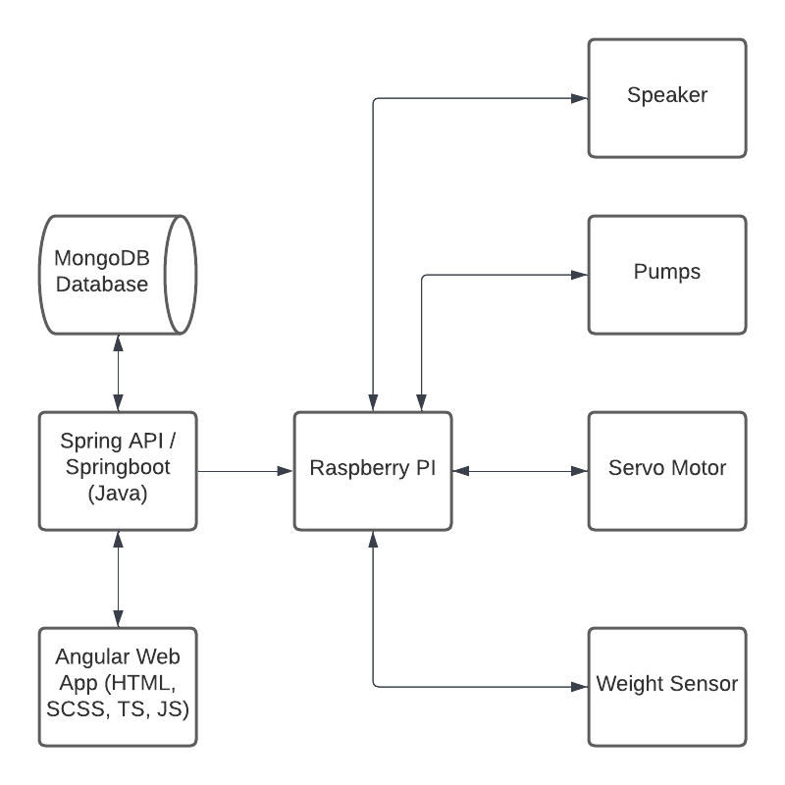

Nginx is an open-source software used for web serving and acts as a reverse proxy for backend content. Nginx uses a master thread to create worker threads to serve web pages. Through the Nginx web server, the user interface and raspberry pi can access information that is stored in the database and interact with the hardware.

The database will use MongoDB to store information regarding the recipes a user can make and information regarding the user’s device. Recipes will be broken down into each instruction into lists of ingredients and appliances with values and specifications for each so that the raspberry pi can communicate what needs to be done effectively to both the user and the hardware.

The user will interact with the device by using the Angular web application. The user will be able to add and remove recipes from the database, select a recipe to begin cooking, and cycle through the instructions. The user will also be able to tell the device to perform a measurement and dispense an ingredient if applicable.

The hardware utilizes a raspberry pi as the primary controller of the hardware. Using the IO pins, the pi will control a flow sensor, a weight sensor, and a servo motor to measure and dispense ingredients according to the instructions it receives from the user. The flow sensor is used to dispense liquid ingredients from the compartments of the device. This sensor measures the flow of a liquid and stops dispensing once the required amount of liquid has been dispensed. The weight sensor is used to measure solid ingredients from the compartments of the device. This sensor measures the weight of a solid and stops dispensing once the required amount has been dispensed. The servo motor is used to rotate a wheel of ingredients. The raspberry pi will have a set position of the location that an ingredient is dispensed and will rotate the wheel until the correct ingredient is at this location. The wheel will be represented by an array in software and will store which ingredient is located in each compartment, whether the ingredient is a liquid or a solid, and whether the compartment is not known to contain an ingredient. The user will have to set the ingredient locations using the device or the web application.

## Complete module-wise specifications

**Raspberry Pi, Sensors, and Servos**

All the electronics are housed within a casing that is 3D-Printed on the top part and a cut plastic container on the bottom part.

A high level design of the circuit and parts list is pictured below:

| | **Item** | **Count** | | --- | --- | | Raspberry Pi | 1 | | Servo Motor (high torque) | 1 | | Motor Breakout Board | 1 | | Liquid Pump | 2 | | Wires | 1 | | Wire Stripper | 1 | | 1Kg Filament Roll (For base) | 1 | | Soldering Kit | 1 | | Weight Sensor | 1 | | Power Supply | 1 | | High level circuit design |
| --- | --- | --- | --- | --- | --- | --- | --- | --- | --- | --- | --- | --- | --- | --- | --- | --- | --- | --- | --- | --- | --- | --- | --- |

As seen in the diagram, the Raspberry Pi is the central control system of the device. All the sensors, motors, and servos are connected to the GP/IO of the Raspberry Pi. This is done through the PIGPIO library. The Raspberry Pi also is the interface between the user, server/database, and IO. The power output of the Raspberry Pi cannot provide enough power to control all devices alone, so an external power supply is used to power the Pi and IO. Since the pumps didn’t have a control pin, Some GPIO output pins were redirected using a breakout board.

The Raspberry Pi hosts a Flask server which is able to receive POST requests from the web server. These POST requests from the web server send a JSON formatted object that contains the information necessary for the Gordo bot to dispense the correct ingredient. When the Raspberry Pi receives one of these POST requests, instructions are read aloud to the user and the Gordo bot dispenses the specified ingredient. The position of the ingredient is read, and a large servo in the center rotates accordingly for solid ingredients.

In the prototype, there are two liquid ingredients, four dry ingredients, and a scale on the base.

Solid ingredients are in a container with a rotating mill that rotates to dispense ingredients. Measuring requires a couple of steps: First, the scale must save the current weight as a reference. Then, the device starts rotating the mill to dispense the ingredient. While this is occurring, the Pi monitors the weight, checking if the difference between the current weight and reference weight is equal to the desired weight. Once this occurs, the mill stops.

The liquid ingredients are kept within two containers with a pump attached to each of them. Using the same mechanism as solid ingredients, the pump shuts off when the desired weight is reached on the scale.

**Database Collections**

Below are the database collections that will be used to organize recipes so that the device will be able to perform operations with the sensors.

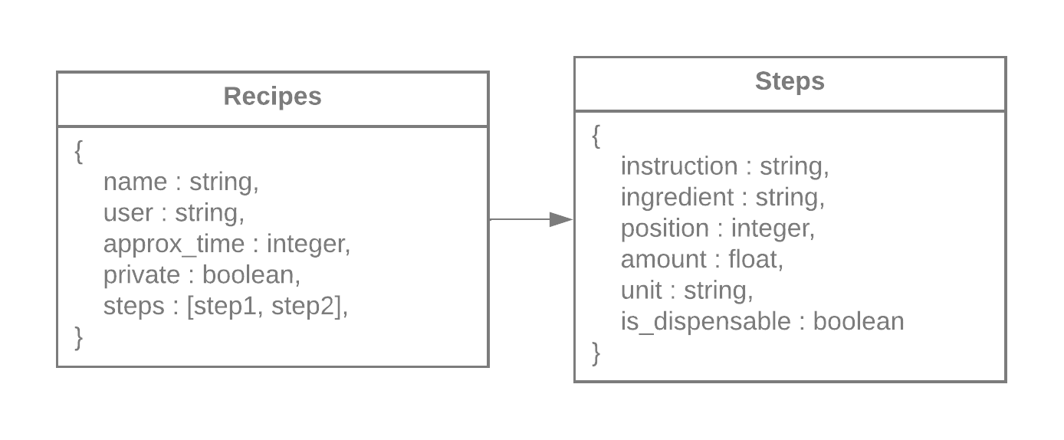

The recipe object will be the primary object for use by the user interface. Users who create their own recipes will insert the recipe’s information into the interface, which will be converted into this format. The recipe object includes the name of the recipe, the user who created it, the approximate time in minutes to complete the recipe, a privacy boolean, and an array of steps. The step object is what will be sent to the robot. This object contains all information relevant to the physical device. The instruction member is the text of the instruction that is to be read out using the text to speech functionality. The ingredient member is for the raspberry pi to perform the proper conversions for the unit and amount variables. There is also a boolean to designate if a step requires a dispense action so that the device can still read the instruction aloud.

**API**

The design of the API will consist of services/functions that can be called in order to connect the bridge between the front-end web user interface and the backend calculation/production function.

An example of this API design in action is outlined below

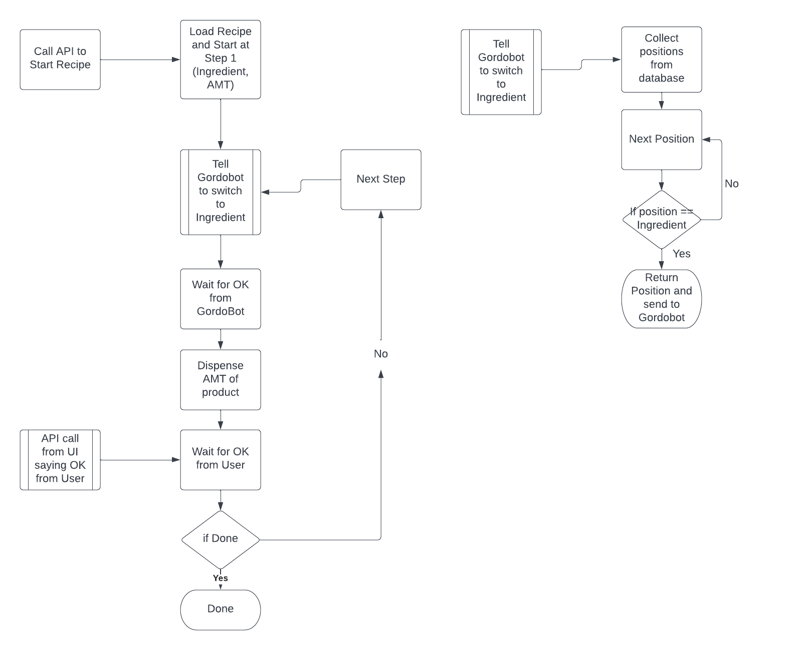

We will implement our API using a technology called Spring boot. Spring framework is arguably one of the most popular application development frameworks used by java developers. All the components of the spring framework are glued together by the dependency injection architecture pattern. Spring boot automates the process of setting up the Spring application (which can become tedious). Spring boot enables java developers to quickly start a new project with all the required spring framework components.

**UI**

The brainstormed picture looks something like the image below. Since we’re not entirely sure yet whether using an API is best, and haven’t been able to test to confirm the current front runner chosen, we’ve tried to design a more general look and functionality that does not require API specifics. The database interactions should be running behind the scenes and not appear too much on the UI. Additionally, we aimed for a design that could be easily implemented on a screen attached to our product or as an independent application interface, so it can be adapted quickly in case of development adaptations. This means that the shapes and organizations were sketched out to be as clean and simple as possible while still retaining appeal.

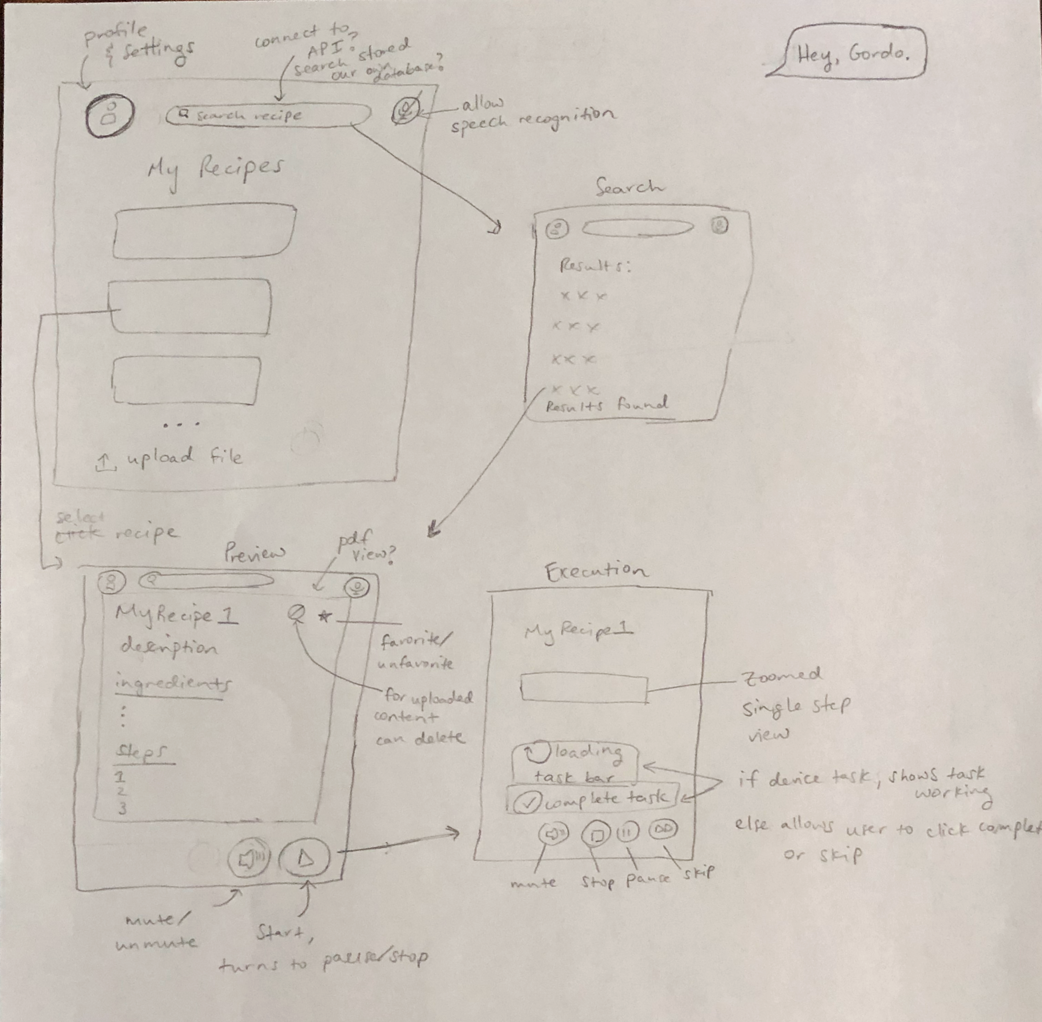

The basic functionality and framework notes were included. The writing is a bit hard to see in the image, but the point still gets across. As for the profile and settings drop-down, it would depend on the interaction with our database and API and will be finalized later. Here, it is not included in order to prevent possible tunnel vision in functionality. At this time, an upload file (ideally pdf) button is included, but may or may not be removed at a later date.

We chose to try a [Figma](https://www.figma.com/file/UpYtq7MbKZcAm6J79e1aGm/UI-GordoBot?node-id=0%3A1) (viewable with the link) to demonstrate this. We haven’t done a Figma before; although it may be possible to create a working prototype, we’re not sure how, and it is a low priority as a demonstration can not be included here. The wireframe result is shown below. At this time the main pages are included and some button functionality is shown.

Upon opening, the home page will come up. It should be a guest-type profile connected to the device unless otherwise specified by a sign-in. A list of favorite recipes are shown, clicking the recipes would redirect them to the preview page, and at this time an upload function is scheduled to be available. On the top, the profile and settings are accessed through the profile icon, the search bar can be used and taken to the search page, and the microphone icon can be toggled to allow speech recognition. On the search page, clicking a result would take it to the preview page, while the Back and Next buttons would scroll through results. The preview page has a back button going to the previous page, a star to toggle favorites, and a cancel button to delete personally uploaded files. The recipe details are listed as parsed by the program, with the option of an attached image. At the bottom is a start button that can be used to run the device with this recipe and a mute toggle option for reading steps aloud (that will transfer to the next page). The execution goes step by step, showing one at a time. It shows a task loading for tasks done by the device, and a mark complete for ones done by the user. The mute button is the same as the preview page, the stop button exits the program to go back to the preview page, and there is a skip button available for skipping tasks.

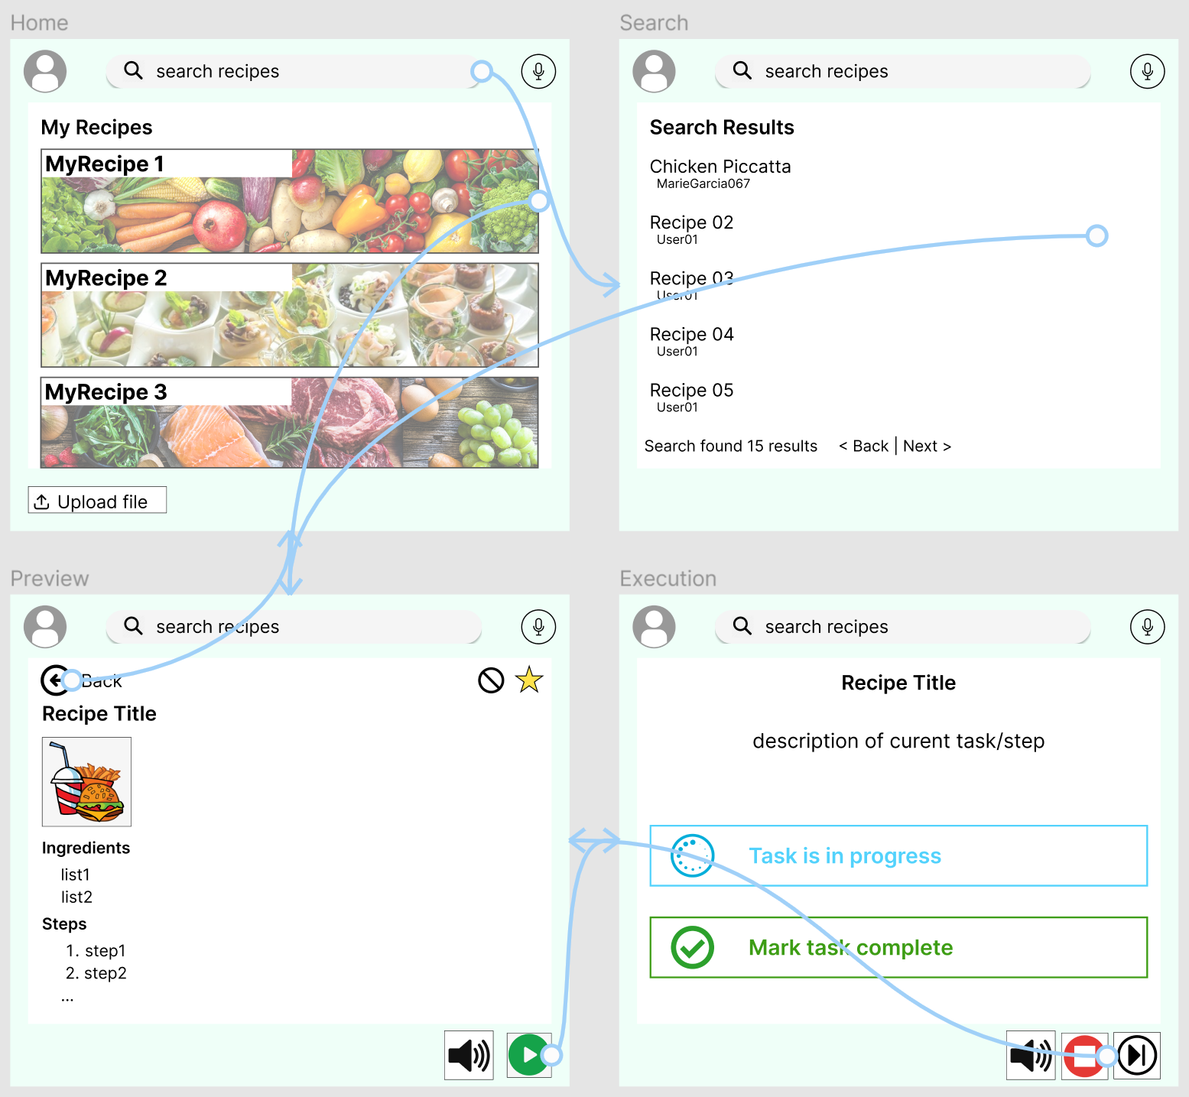

## Approach for design validation

After all components (the front-end, server, database, hardware, etc.) are confirmed to be independently functional, the systems will be combined and a basic test will be performed using the complete flow of the device with each member verifying that their component behaves as expected. In general, the flow will start with user input on our Angular Web to our interfacing API. The Spring API communicates with our NGINX web server, pulling the necessary data from our MongoDB Database. The web server then sends the data to the Raspberry Pi. The Pi parses the data, using CircuitPython to perform the action that completes the indicated task. The flowchart below visualizes this general flow.

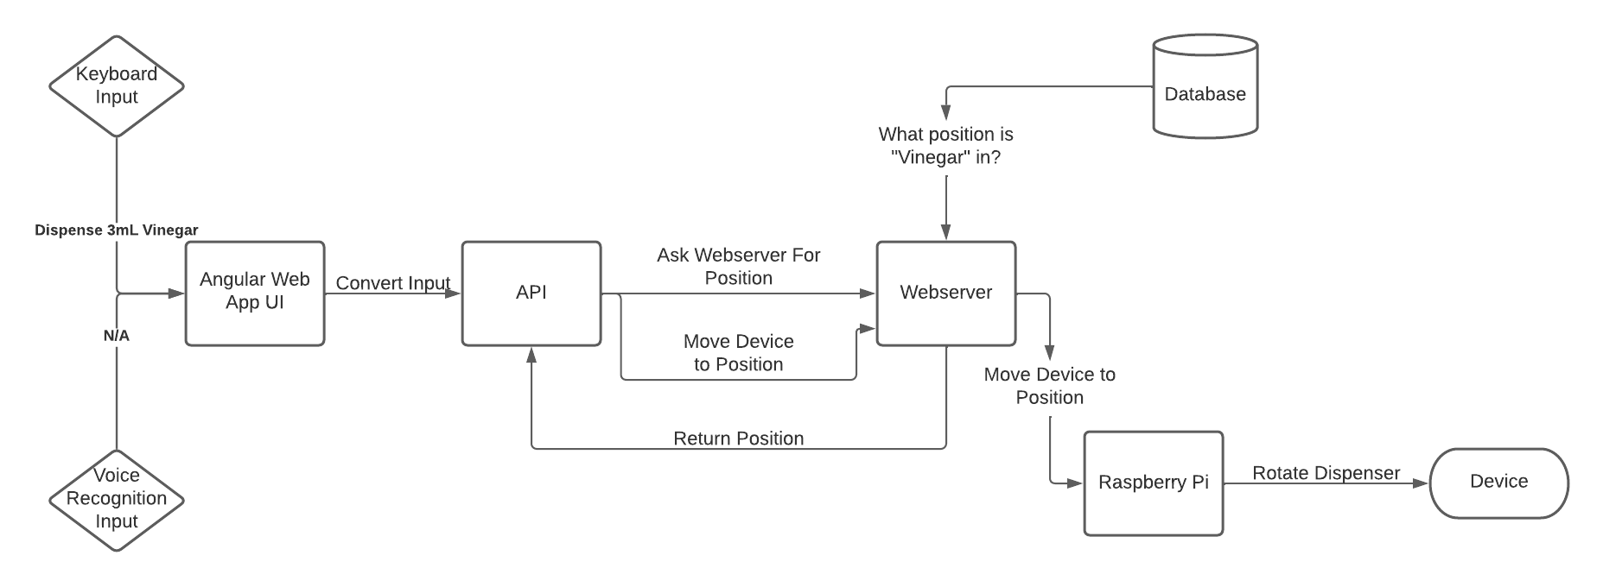

In our initial tests, the team member responsible for a given step in the flow verifies that the component took in the correct inputs and gave the expected outputs. The behavior for each step should be verified. For example, the Raspberry Pi should receive a JSON to parse from the web server. The person responsible for the Raspberry Pi interfacing should check that the JSON file is formatted correctly and that the Pi correctly parses/enacts the contents of the JSON. These initial tests are taken slowly to ensure the design works together as a unit. This stage is only expected to complete very basic “recipes,” such as dispensing 1 cup of water. After the basic flow works correctly, then the next stage of validation occurs.

This stage of validation can be considered the “controlled” use case, meaning that the device is used in its expected manner, but with very specific recipes. At this stage, we will use hand-curated recipes with relatively simple steps and use the device how a user might. The recipe’s steps at this point should only contain tasks that can be performed by the Raspberry Pi and its IO. In practice, this is dispensing different variations of ingredients with varying amounts of each ingredient. The system will be looked at as a whole at this point and is only considered validated if it functions correctly from start to finish. This means the device should be able to allow a user to select a recipe and have that recipe produced exactly as described) If something fails, then we trace the steps and identify the cause, alleviating the issue and trying the test again.

For the final stage of validation, the device should be fully functional. At this point, users should be able to choose more complex recipes that require user intervention (such as baking the ingredient mix after it has been dispensed). The user should be able to seamlessly continue recipes after these steps and have the device perform the next step. Validation in this stage is considered successful if a user is able to choose a complex recipe, follow the steps provided, and successfully cook the recipe.

To ensure the device satisfies the need, a few random users can be given the device to cook a recipe. After using the device, the users will be asked to provide feedback, specifically if they felt this device made cooking easier and more convenient.

# Implementation notes

## Database and Docker Container

Below are the steps to install and use docker.

install docker from the docker website (whichever version you want)

execute this command in the terminal (The location for mac is “/usr/local/bin/docker-compose” and “/usr/bin/docker-compose for Linux unless another folder is selected)

/usr/local/bin/docker-compose -f */docker-compose.yaml up -d

the docker instance is now running

navigate to http://localhost:8081 to examine database

## JSON Objects

The system recognizes two main JSON objects used throughout the user interface and raspberry pi to successfully display recipes and dispense ingredients, divided into recipes and steps. An array of steps is a member of a recipe. The full description of these objects used can be found in the Final Design section of this document.

## Raspberry Pi Software

Needed software:

* Python3

Python libraries to install:

* Flask, flask-cors, gTTS, mpyg321, mpg321, pigpio, json, request

The files used in the Raspberry Pi consist of the following:

* app.py - Contains the Flask server and routing details
* g_pump.py - Controls the pump mechanism
* g_servo.py - Controls the servos
* handler.py - Endpoint for data from server
* hx711.py - A custom library to control the scale (From [here](https://github.com/tatobari/hx711py/blob/master/hx711.py))
* maincontroller.py - Hardware controller
* send_step.py - python program for local testing

Useage consists of first starting the Flask server on the Raspberry Pi

$ app.py run

And then either waiting for an external instruction from the database, or sending a test instruction locally

$ python send_step.py

App.py

app = Flask(__name__)

Initialization for the Flask app

CORS(app)

Allows CORS for all domains on all routes on the Flask app

@app.route(“/post_json”, methods=[‘POST’]

This line declares the wrap on the following process_json() method and that information received through a POST request at the /post_json URL will be redirected here.

data = json.loads(request.data)

loads the JSON data from the POST request into the “data” variable

request_handler(data)

Sends received JSON data to the handler function located in handler.py

app.run(host=’0.0.0.0’, port 5000)

Tells the Flask server to listen on all available IP addresses at port 5000 for a request. ‘0.0.0.0’ can be changed to a specific IP address. To figure out the external IP address to send requests to, use “$ ifconfig” and look under the entry “wlan0” for wireless connections.

Handler.py

instruction = data[“instruction”]

This line and the similar ones underneath it load the data from the JSON object into local variables

myobj = gTTS(text=instruction, lang=’en’, slow=False)

Sets the text-to-speech options. The text being converted to speech here is the string contained in the instruction variable.

myobj.save(“instruction.mp3”)

Saves the text-to-speech audio file as “instruction.mp3” in the current directory

os.system(“mpg321 instruction.mp3”)

Plays the text-to-speech file using the mpg321 audio player

if (ifActionable == False)

Does not proceed any further if the step does not include actions that the Gordo Bot needs to perform. The instructions will still have been read out loud to the user at this point, however.

if (unit != ‘grams’)

Starts unit conversion process if the unit is not already in grams

if (unit != ‘liters’)

Converts any unit not already in liters to the volumetric measurement liters. Future updates could cover a larger number of less used units that need to be typed in manually here.

if (ingredient == ‘water’)

Converts ingredient amounts from liters to grams using the density of ingredients. For example there, there are 1250g in 1L of salt, so the formula is amount_grams = original_amount * 1250. Future updates will need to add more ingredient conversions here to cover a wider range of possible ingredients.

executeStep(destinationPosition, amount_grams)

Passes the container the ingredient is stored in and the amount of it to be dispensed, in grams, to the device controller in maincontroller.py

g_pump.py

TopServo class

Makes use of the pigpio library to control the main servo used on the project. The initialization of this class sets up the appropriate pins to be used by the servo, its frequency given by the DS3218 datasheet, and the initial pulse width modulation necessary to move the servo to its 0-degree position. The pi must be running the pigpiod daemon for this library to work.

TopServo.changeIngredient(self, ingredientPos)

Changes the pulse width modification of the servo moving its stop position to a new chosen ingredient. Ingredient positions 0, 1, 2 and 3 are given the 0-degree, 90-degree, 180-degree, and 270-degree angles respectively. This is set by modifying the pulse width modulation according to experimentally determined positions (derived from the positions on the datasheet).

pwm.set_servo_pulsewidth(TopServo.servo, TopServo.offsetPWM)

Applies the given PWM to the given GPIO pin specified by servo, from the pigpio library

TopServo.dispenseIngredient(self, weight)

Given a mass (in grams), the currently “active” ingredient determined from changeIngredient is dispensed until the scale determines the mass dispensed is equal to the given weight variable.

This is done within a while loop that constantly checks the value of the scale and “shakes” the servo until the correct amount has been dispensed.

The shaking occurs from rapidly setting the PWM between the position PWM and some offset.

If the value is not achieved after 20 seconds, it times out and returns.

On failure, the servo’s position is set to the offset to prevent spilling.

The hx711 library has a variety of functions to communicate with the hx711 scale, the ones described below are used within this function:

hx = HX711(5, 6)

Sets the input and output pins of for the scale

hx.set_reference_unit(477)

An experimentally determined value used to calibrate the scale. This value is derived from measuring the value of something with known mass and using the output value as a ratio with the actual mass.

hx.reset() and hx.tare()

Resets and “zeros” out the scale

g_servo.py

Pumps class

Makes use of the builtin RPi.GPIO python library to control the main two pumps used on the project (along with a breakout board to drive the pumps as if it had an input pin with its power pins). The initialization of this class sets up the appropriate pins to be used by the pump. The 2 input GPIO pins for each pump are simply driven high and low to activate the pump.

Pumps.dispensePump(self, ingredientPos, weight)

Given a mass (in grams) and the position of the liquid ingredient, the respective pump dispenses liquid until the scale determines the mass dispensed is equal to the given weight variable. This function is equivalent to TopServo.dispenseIngredient(self, weight) and follows the same logic. The only difference is the pump is activated rather than the servo shaking the ingredients.

If the value is not achieved after 20 seconds, it times out and returns.

On failure, all of the pins for the pumps are set to the low to prevent leakage. The hx711 library is used exactly the same way as described previously in the TopServo class.

maincontroller.py

executeStep(ingredient, weight)

Checks if a given ingredient position is within the accepted range (0 to 3 for a solid ingredient, 4 to 5 for liquid). And calls the respective controller class based on the ingredient position given.

Solid ingredients instantiate the TopServo class from g_servo.py and call the changeIngredient() and dispenseIngredient() functions to choose and dispense a given ingredient.

Liquid ingredients instantiate the Pumps class from g_pumps.py and calls dispensePump to choose and dispense the respective ingredients.

GPIO.cleanup()

Performs cleanup on the Pi’s GPIO pins so that there are no residual signals being sent to the hardware.

## Angular Setup

resource for installation: <https://angular.io/guide/setup-local>

resource for ionic addition to angular: <https://ionicframework.com/docs/intro/cdn>

resource for tutorial used as the foundation for site: <https://angular.io/tutorial>

This resource is Angular’s “Tour of Heroes” tutorial that includes things like creating a framework, making new pages and functions, navigation, search bar, and accessing a database. It was very close to what we needed and allowed us to quickly pick up some uses of Angular. The pages, framework, and functions were changed to adapt to our needs. Some pages and features were added to fit our original design sketches and proposed functionality, and the CSS was developed separately. During the development, while the database was being created, a dummy database shown in the tutorial was used instead. Corresponding class files for our JSON objects were added as needed to accommodate data structures to be passed in, and further modified as the project developed. A couple of buttons made just in case they could be used later for our stretch goals were, unfortunately, not met and later removed.

In integration with the database, it now requires IntelliJ and docker to run correctly.

# Experimental results

To ensure the quality of the Gordo Bot there were countless tests that the team collaboratively conducted. A significant portion of the tests were on individual components, while some were testing the machine as a whole. Although many of the individual components arrived later than expected, we still tested each to ensure that they worked fully. The components tested in this portion of the project were the servo motors, flow sensors, weight sensors, as well as the pump to dispense liquids. In the following sections below, there will be a brief description of how each of these components was tested thoroughly.

Individual Component Testing

The servo motors were tested by inputting specific angles and recording how accurate those rotations were. For the most part, the servo motor was almost 100% accurate. Even in the case that there was a little bit of error, it would not be a significant issue since there are a total of four compartments meaning each compartment was about 90 degrees wide. In a Gordo Bot system that consisted of more than four compartments then the servo motors would have to be a little more accurate.

The flow sensors were tested in a similar fashion, where we would allow a certain amount of seasoning to flow through it and have it cut off when an accurate amount was dispensed. The flow sensor was also rather accurate since measurements were rather small (only a few grams) variance did not appear to significantly affect the output of the Gordo Bot. However, we initially did receive significant variance in the number of ingredients released and it always seemed to be less than the intended value. After further research, we came to the conclusion that some of the ingredients were spilling out of the machine and not flowing into the container. Luckily, once everything flowed through the Gordo Bot and into the container the value that was released was cross-checked by the reading from the weight sensor sitting below the container.

The weight sensor on the bottom of the Gordo Bot was tested by applying weight via adding various ingredients into the container sitting on top of the sensor. The values for the weight sensor as well as the flow sensor were almost always the same, with very little variation. Variation was always minimal and never too drastic to notice any kind of inconsistency. Since the weight sensor, as well as the flow sensor, were working together we never received an issue with improper dispensing amounts.

UI/Database Testing

To test the UI and database integration we ensured that all data was accurately transferred back and forth. We tested this by interacting with the UI and various manners attempting to utilize all of the features multiple times to ensure a consistent front end to back end integration. These tests included adding new recipes, using other user-created recipes, and adding ingredients. All of these tests properly updated MongoDB 100% of the time. There was never an inconsistency with the front-end to back-end communication. Most of these tests were inevitably tested in the next section when we tested the device as a whole. Luckily, we never had any difficulties or potential problems with the UI and database.

Wholistic Gordo Bot Testing

After we were confident in the ability of each of the components listed above we then tested the system as a whole. Our tests consisted of the following methods: uploading new recipes/ingredients and testing how the system handled it, attempting following a recipe and cooking a meal, testing the approximate duration for dispensing various ingredients, and how much time the average individual is saved by using the Gordo Bot. Each of these was tested thoroughly and the results are shared in detail below:

The first test was to ensure that the Gordo Bot could properly handle the process of uploading new recipes/ingredients. We tested this by first adding a new recipe using the UI and seeing if it appeared in MongoDB, which it successfully accomplished. We then tested to see if adding new ingredients would update the UI and furthermore dispense the correct ingredient on the Gordo Bot. Both of these tests consistently passed. The pi was always aware of the container that the servo motors will rotate you and the MongoDB database always had the newest and updated values.

The second main test on the Gordo Bot as a whole was to actually make a meal and have it guide the user through the appropriate steps. We created a simple recipe with salt and pepper to make scrambled eggs. We followed the steps that we had previously set and the Gordo Bot properly dispensed the current ingredients and amounts as well as waited for the user to put the eggs on the stove before proceeding to the next step.

The third test was the total duration between pressing a dispense function on the front end application and the ingredient completely filling the container with the required amount of ingredients. The average time for the Gordo Bot to start dispensing after pressing dispense on the front end application was approximately 4.5 seconds. The dispense duration varied drastically on the type of ingredient (solid or liquid) as well as how much. Overall, having the Gordo Bot respond within 10 seconds is all that is needed for efficient cooking, so the Gordo Bot has surpassed that threshold.

The fourth and final test was on the average time a user saves when using the Gordo Bot as opposed to traditional cooking methods, in which finding as well as measuring ingredients consumes time. Generally speaking, the longer that the recipe was and the more steps there were in the recipe, the Gordo Bot saved an increasing amount of time at an exponential rate. After some user testing, we came to the conclusion that for each ingredient that is required in a recipe the user is saving approximately 65 seconds. This calculation takes into account the cleaning process of measuring tools, retrieving ingredients, following a recipe off of the internet, as well as actually measuring each ingredient. Since the Gordo Bot allows the user to cook something on a pan while the necessary ingredients are being dispensed, a significant amount of time is saved. Using the value of 65 seconds per ingredient, using a recipe that requires all 6 ingredients in that machine, the Gordo Bot could save the user 6.5 minutes. So a recipe that would initially take 12 minutes would take less than half the time. While these values may drastically vary depending on the recipe, the Gordo Bot will almost certainly save the user time.

After intensive testing on every aspect of the Gordo Bot, the team can confidently conclude that Gordo Bot will consistently fulfill its purpose of saving the user time when cooking various recipes. Every temporary issue with the product has been fully recovered and a user should be able to use the device to its full potential without any concern.

**Fig. 5.1 Dispensing Liquid Fig. 5.2 Dispensing Solid**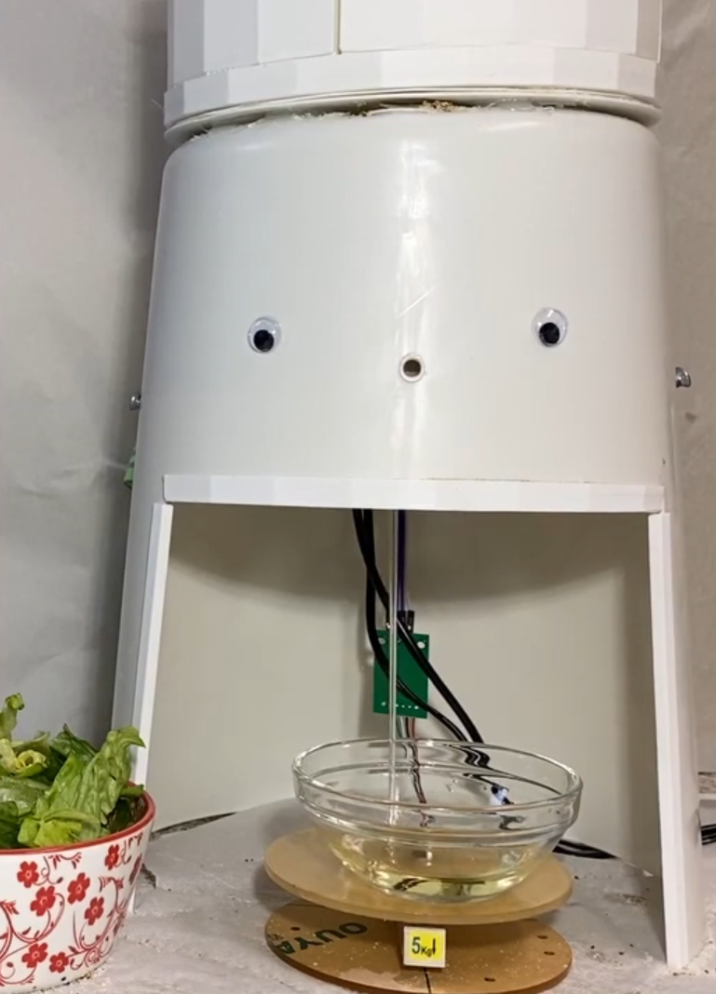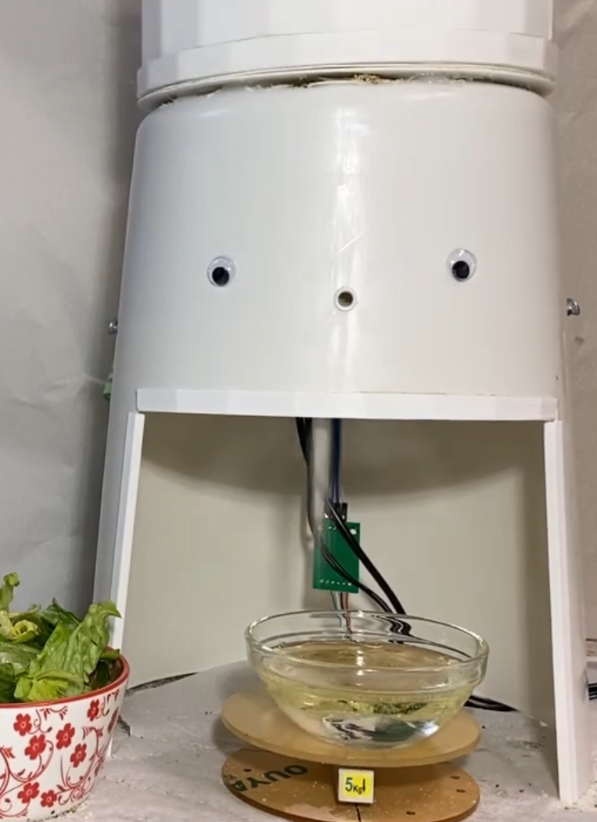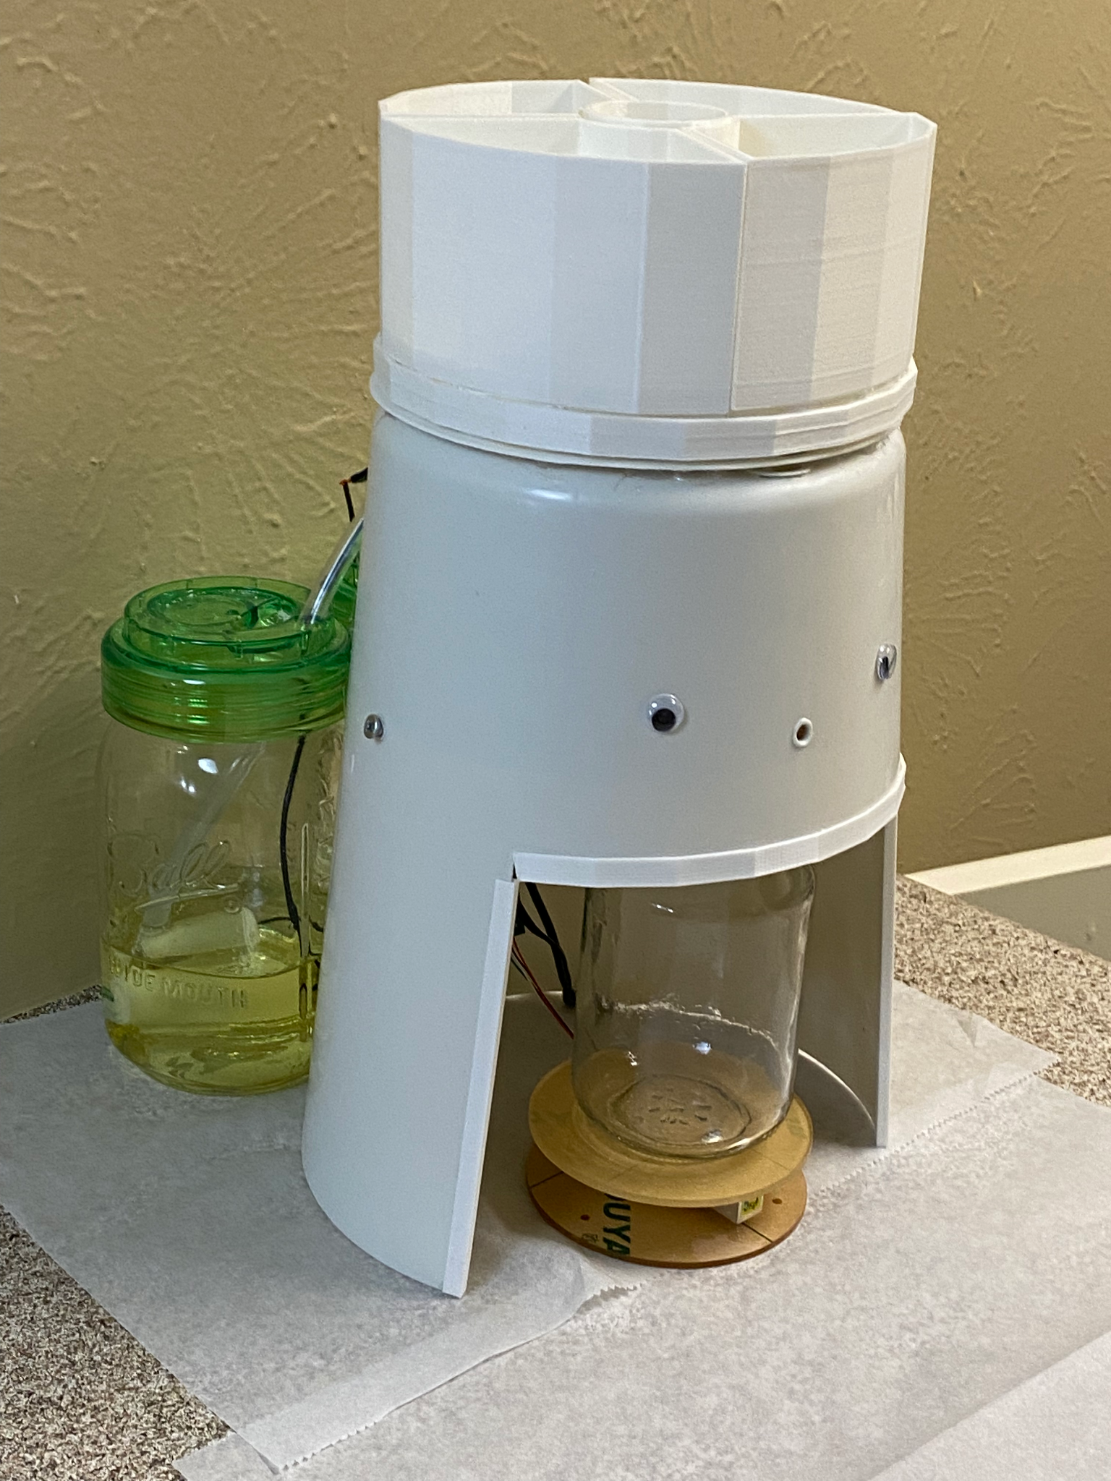

**Fig. 5.3 Early Draft of Gordo Bot Fig. 5.4 Side View with Ingredients**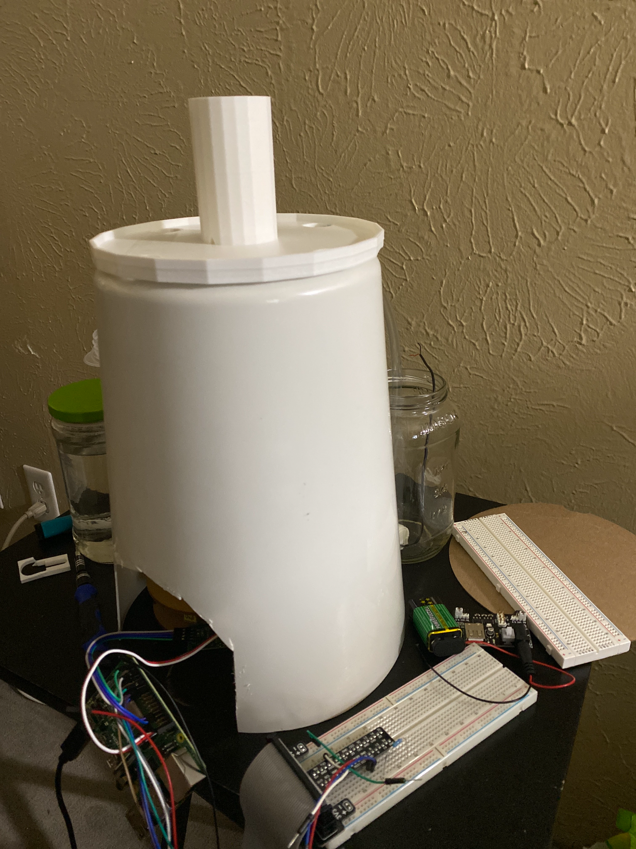

**Fig. 5.5 Demonstration of Wiring Fig. 5.6 Pi Attached to Bottom**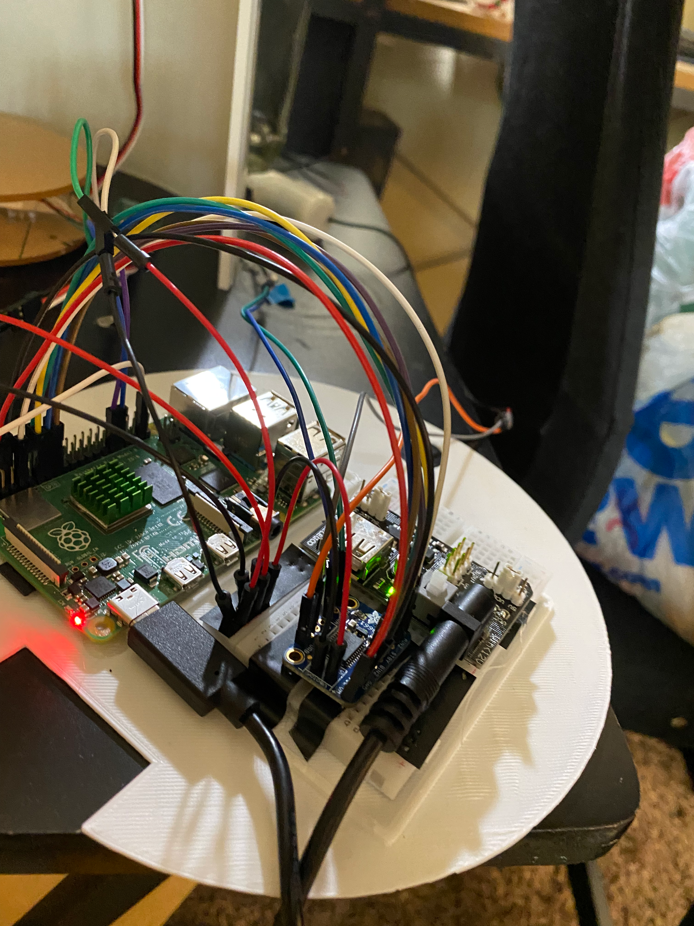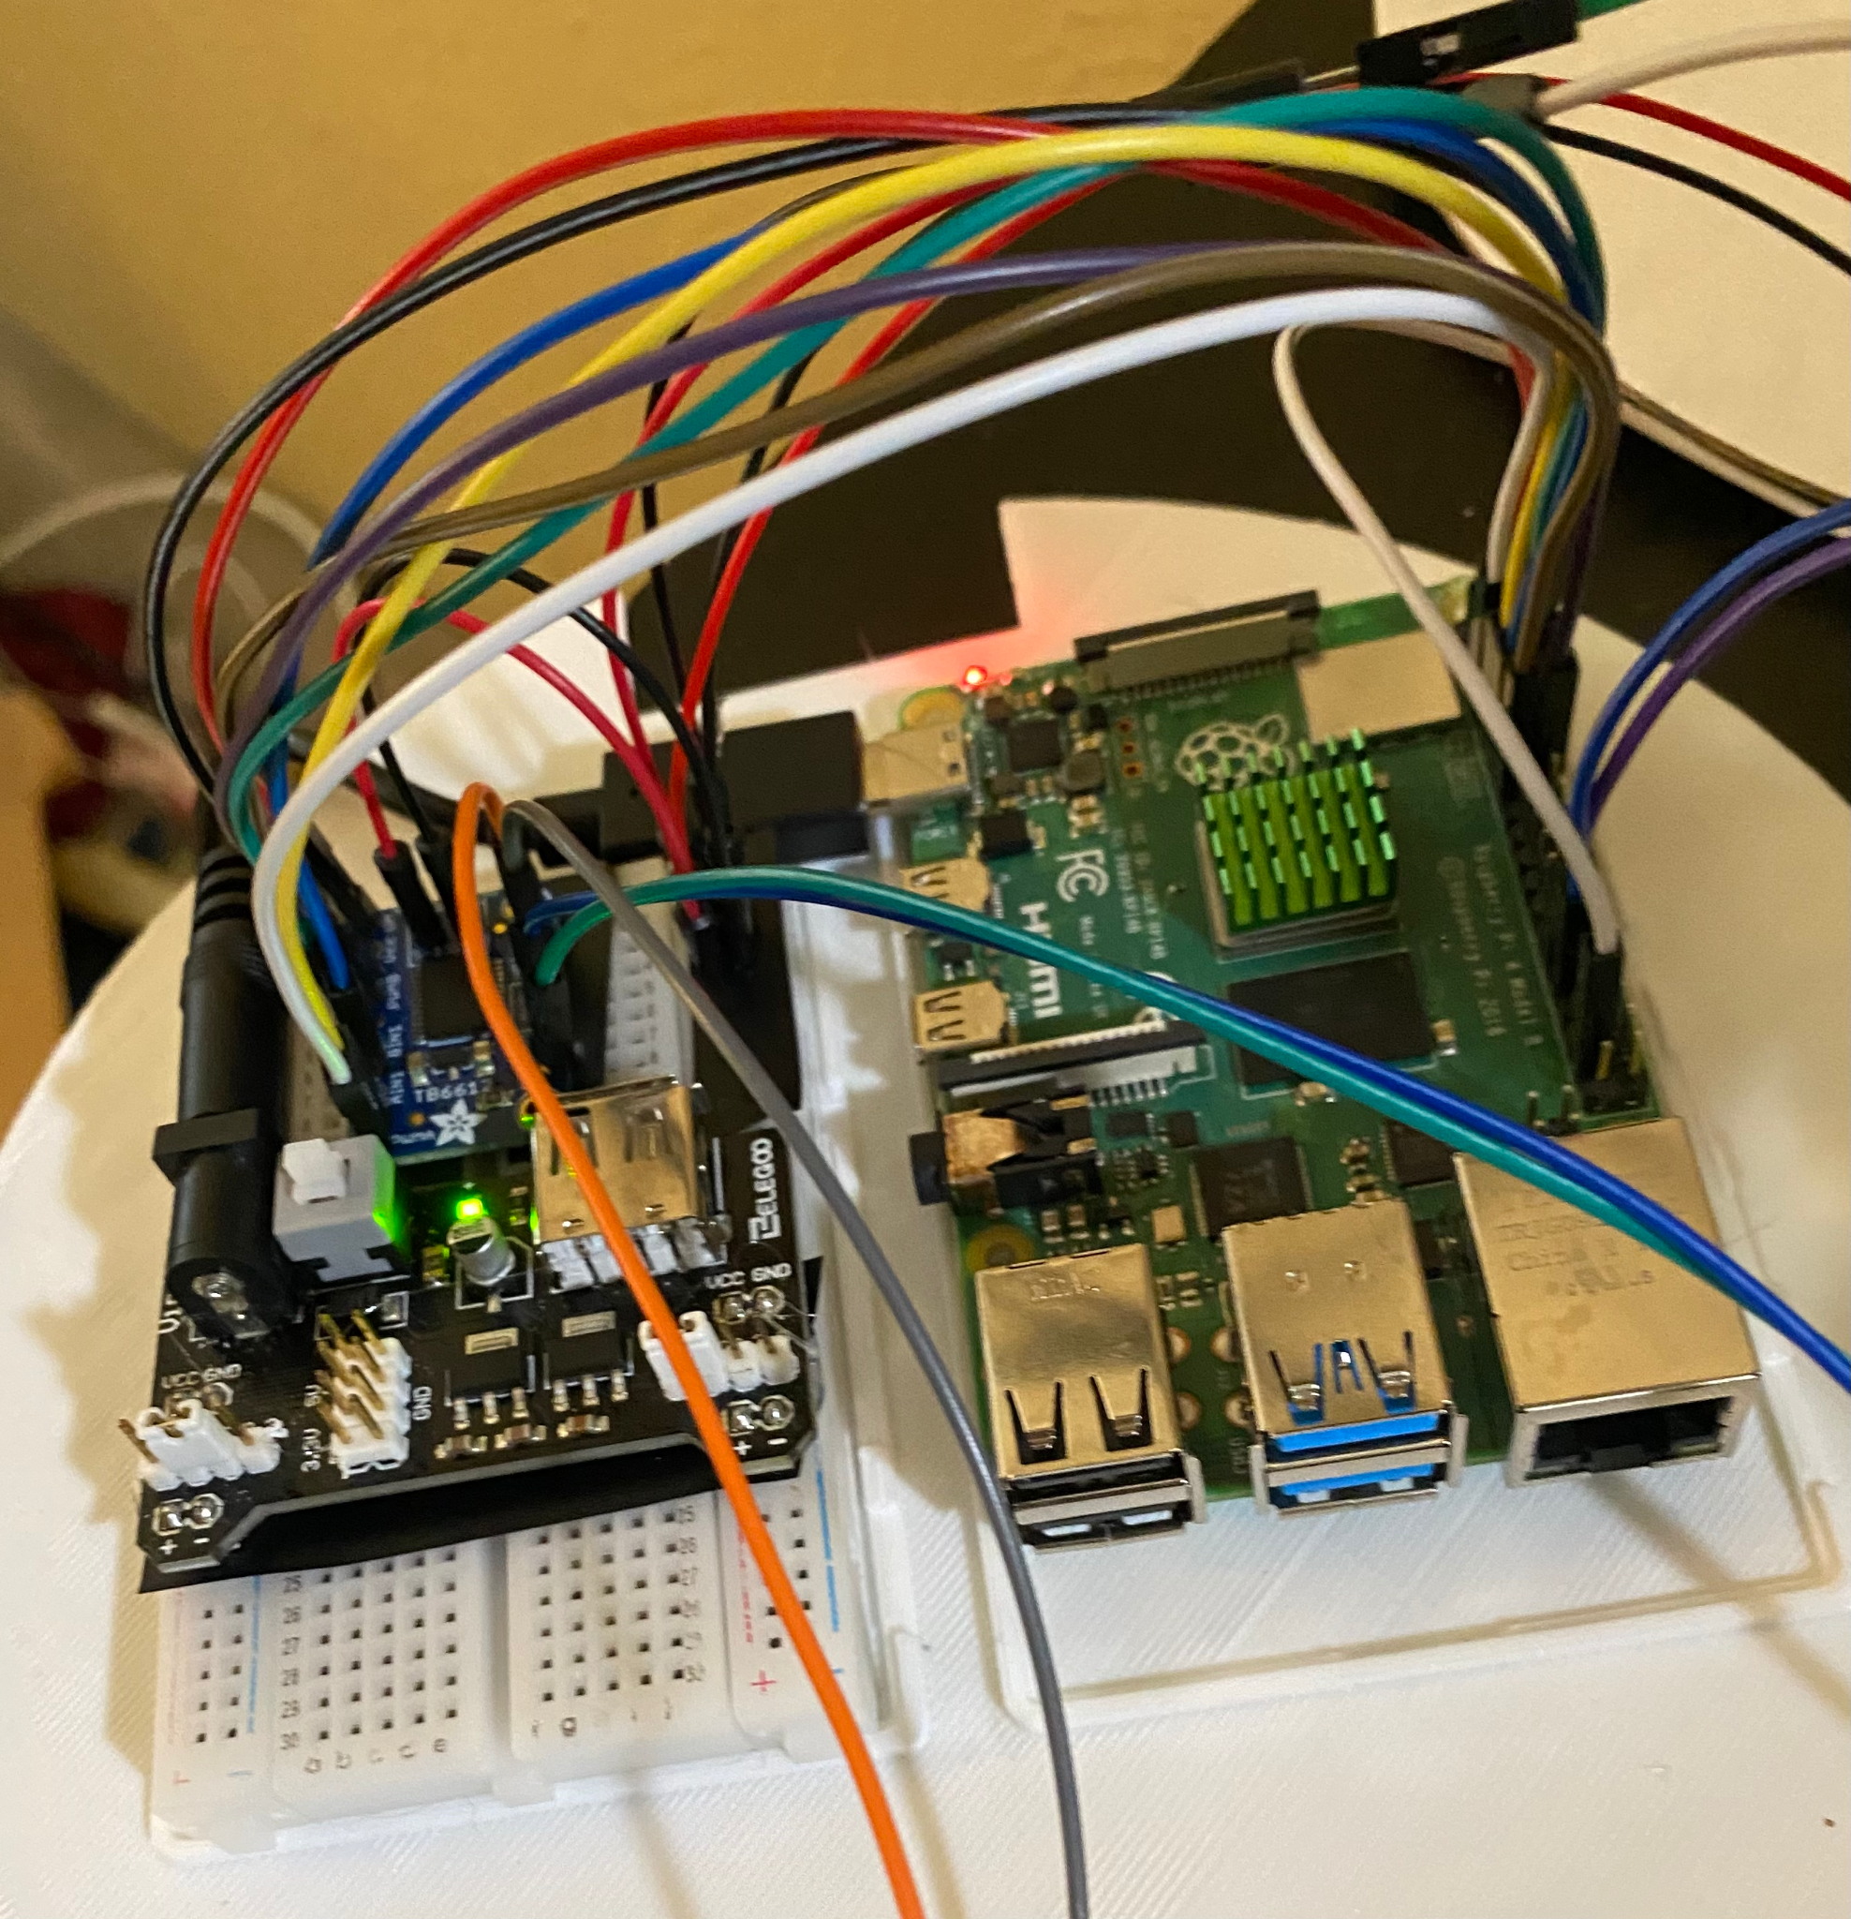

# User’s Manuals

Average User

The average user of this device is considered to be amateur chefs who are learning to cook. An amateur chef is defined as a person who may lack some fundamental cooking skills but is able to prepare ingredients and attempt a recipe.

Hardware Installation:

This product comes mostly fully assembled. All the electronics are stored internally, with the exception of the scale. The user should connect the four pins of the scale to the exposed four pins coming from the top of the device. Each of the four pins should match the four pins coming from the device, so assembly just requires the user to match the colors.

There is additional assembly needed for the ingredients. The user should put all four dry ingredient compartments within the included base of the device. The holes on the bottom of each compartment should line up with the holes seen on the base of the device. Once assembled, the user should fill each compartment with ingredients according to their desired recipe or most used ingredients.

For the liquid ingredients, the included mason jars should also be filled with the desired ingredients and be screwed into the included jar lids. The user should ensure the pump is fully submerged to ensure that the device has liquid to pump.

For communication with the database, the Raspberry Pi should be connected to the internet. This is most easily done with an ethernet cable.

Once all the ingredients and scale have been assembled and added, the device is ready to use according to the following instructions for the software and general operation.

Software Installation:

For the sake of this prototype, everything is hosted locally, but ideally in a real deployment, the database and site would be hosted on a server and Pi would be connected to the internet through a wired connection that does not require the user to modify the Pi’s setup. So, the only required step for the user would be to visit the public webpage.

However, currently, the user should install the perform the following steps:

Install intellij from Jetbrains.com

Select the pom.xml file when opening the Gordo Servo project in intellij

Install docker from docker website (whichever version you want)

Execute this command in terminal (/usr/local/bin/docker-compose location may be different for OS, i am using a mac)

/usr/local/bin/docker-compose -f <Project Path>/gordo-api/docker-compose.yaml up -d

Run GordoAPIApplication.java with intellij

For the UI, install NPM and in the Gordo UI directory:

* npm uninstall -g @angular/cli

* npm cache clean (may have to use —force)

* npm cache verify (if npm > 5)

npm install -g @angular/cli@9.1.5

ng serve

The site is available to use at http://localhost:4200

Operation Instructions:

The user may start by selecting a publicly available recipe or by adding their own recipe to the system. Below is an image of the recipe list.

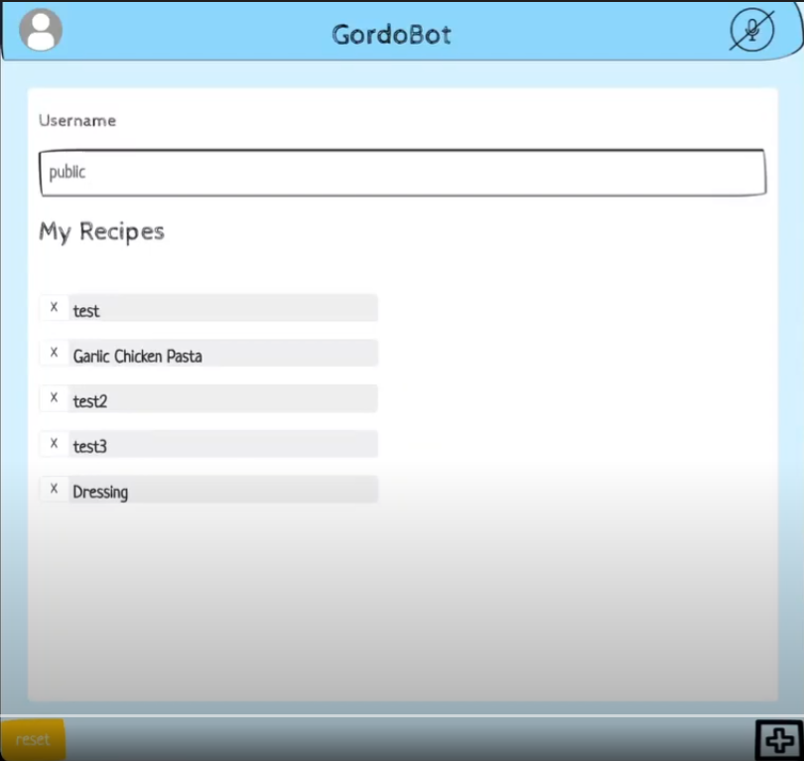

In the current state of the product, you must break down steps that do multiple things into simple, single-action instructions that can either be followed by the device or performed by the cook if a dispense action is not necessary. Currently, each ingredient must correspond to a position (0 to 5) on the physical device, which can be entered as part of the step information when creating a recipe. Below is an example of the creation process.

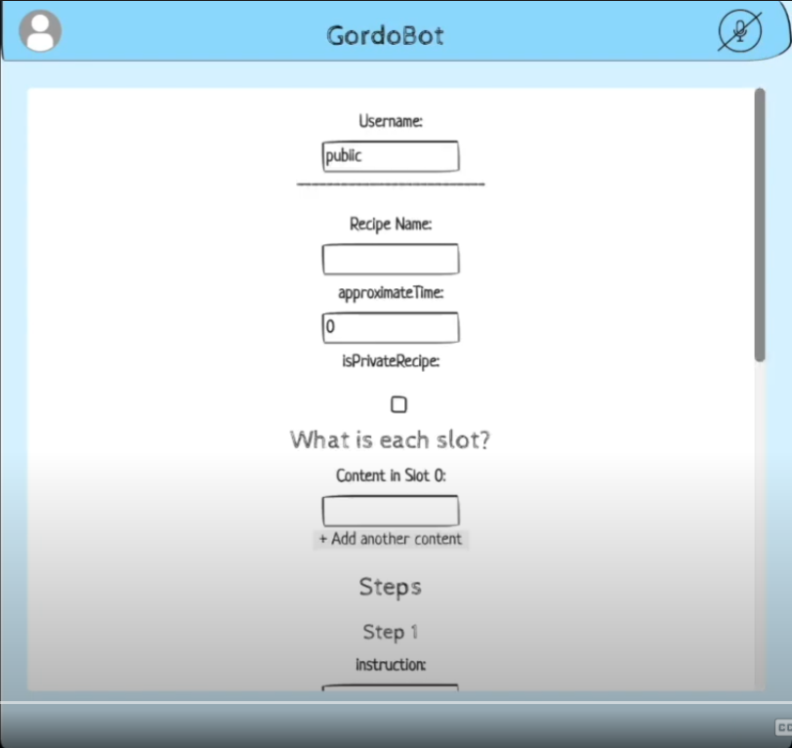

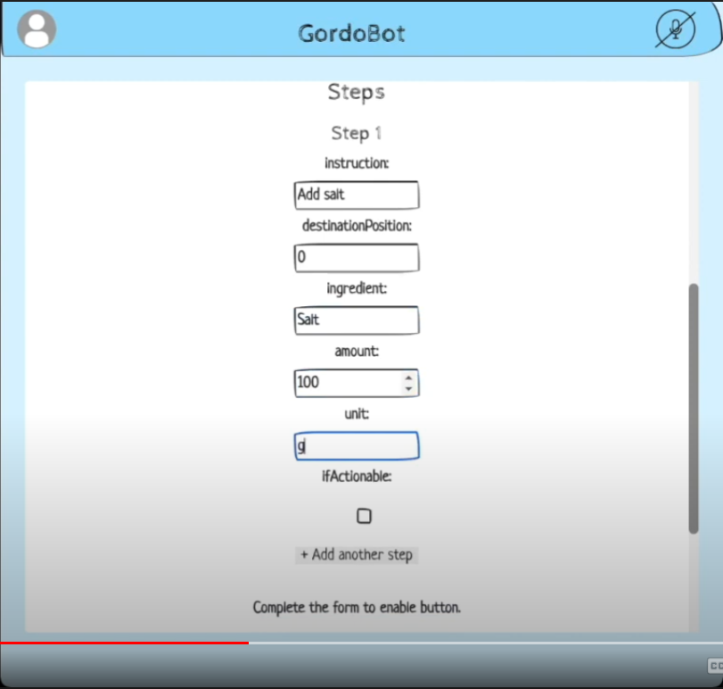

If you have trouble viewing a recipe that has been created, you should first be sure that the proper username is selected and check if the recipe has been marked as private. See the image in the initial step for the username textbox above the recipe list.

Once a recipe has been selected, you may begin following the recipe’s instructions. When a step has been completed, the user may proceed to the next step by hitting the “Next” button. If a step requires that an ingredient be dispensed, the “Next” button will also trigger the dispense action, and it is important that you add the required ingredients to the device in the proper positions before steps that require dispensing occur. Below is an example of a recipe that is currently in process and is ready to dispense an ingredient.

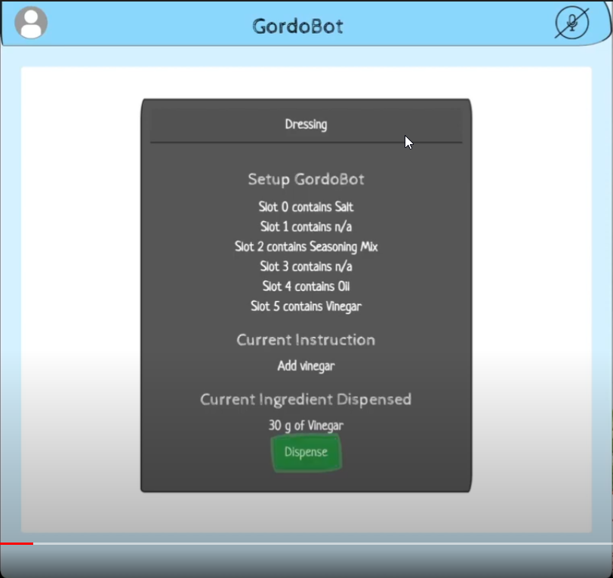

Once the end of a recipe has been reached, you may select “Finish” to complete the recipe and repeat the process again if you so wish. Below is an image of a recipe that has reached the end.

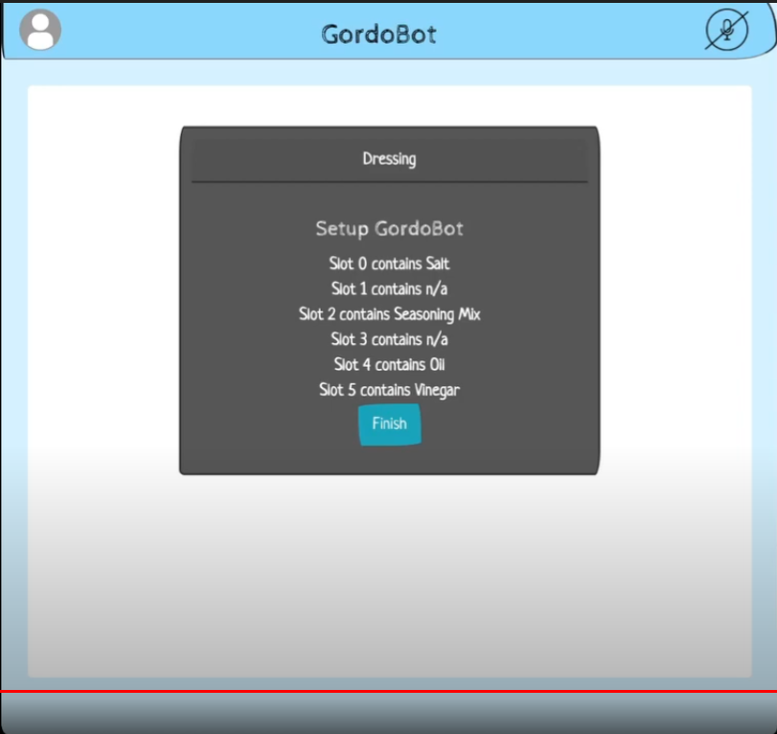

# Course debriefing

Team Management

Our team management style was generally a democratic approach. When we ran into issues that required us to edit our original design, we would ask for everyone’s input and advice regarding the change before pursuing the redesign. This way, we could know how the change would affect everyone’s portion of the project. This also meant that if anyone had any prior experience, they could help us better understand and implement the change.

Our project was pretty nicely divided into neat sections to split among the group members to work on. Each person had their topic (database, hardware, ui, server, etc) to work on individually, then integrate and collaborate on during team meetings. This meeting style resembles an agile development process. However, as we did not have a fully functional prototype until the end, our process was generally more linear in following a typical waterfall development. Each person worked in parallel linearly on their own pieces, sometimes working in pairs or groups to add things necessary for integration but not merging together as each still remained individual until the end product. This individual approach worked very nicely for us as it was often hard to find time for the whole group of 6 people to be able to meet and discuss outside of class, so working individually or in pairs when needed was a much more convenient and efficient method.

However, we could have benefitted from adopting more scrum meetings with more in-depth updates so that everyone knows the details of all other sections rather than the progress status or simply details related to their portion of the project. We could have regulated more soft benchmarks or goals within the team to enforce, especially in cases of features dependent on other sections. This would have helped us a lot as in the end we faced some delays due to bugs in total integration.

Unfortunately, we also all were not very fond of documentation, often putting off writing until the last minute. We definitely could have found a system to go about this in a better manner, with an emphasis on improved time management.

Safety and Ethical Concerns

A safety concern that is possible is the interaction of liquid ingredients in the container and the electrical wiring in the device. In normal operation, these two parts should not touch, but it’s possible that if the machine tips over or any liquids splash out it could hit an electrical wire and cause an injury. In later iterations, this could be avoided by having more watertight seals around the electronic components and less able to interact with the electronics. Another possible solution to this would be to have lids on each of the containers. The containers currently have open tops, and this could also allow for possible contamination of food items. Having lids on the containers would minimize possible contamination and prevent spillage.

Ethically, the data stored is relatively low-risk as there is no critical personal information stored. Even so, we have implemented a field allowing users to choose to have their recipe public or private to control access. If someone were to post a copyrighted recipe, it would pose a problem. It would need to be reported, then verified, and taken down by an administrator.

Testing

As described in section 5 of the report, the team tested the project thoroughly by first testing each hardware component of the Gordo Bot. After ensuring that the servo motors, flow sensors, and weight sensors were accurately returning precise measurements, we tested the UI and database. Rigorous testing on the UI as well as its ability to fluidly communicate with the database was conducted to ensure that no data was lost or steps missed. Once the separate components of the Gordo Bot proved to be completely accurate we proceeded to do holistic tests that engaged every feature of the Gordo Bot. An example of a holistic test that we conducted was creating a new recipe (ensuring it was stored in the database), then proceeding to follow that recipe step by step (ensuring that Gordo Bot was dispensing the correct ingredient as well as the correct amount). There were some edge cases that we tested. For example, we added functionality to prevent the Gordo Bot from crashing when the user would quickly go through all the steps, spamming the dispense button. The pi will manage each request one at a time, storing them in a queue. Ideally, if we were to do this project again, we would allocate additional time to test the system as a whole. There are many edge cases regarding the dispensing of ingredients and the interaction with the user interface. Under certain circumstances, there was latency between hitting the next button and dispensing the ingredient, resulting in downtime that would be irritating to users who were already stressed about beginning their cooking journey. Additionally, there are many ingredients that a user may need to dispense from the device that may use different measurements, which would require us to cover in the python code on the raspberry pi and test to validate that the measurements meet our standards, and with additional time, could be done.

# Budgets

Much of the cost of the prototype was offset by using parts already in our possession. however if one were to build the device from scratch the parts list would break down accordingly:

| Item | Count | Cost | Link |
| --- | --- | --- | --- |
| Raspberry Pi 4 | 1 | $ 45.00 | <https://www.raspberrypi.org/> |
| Servo Motor (high torque) | 1 | $ 17.00 | <https://www.amazon.com/ANNIMOS-Digital-Waterproof-DS3218MG-Control/dp/B076CNKQX4/ref=sr_1_6?crid=3OGLXRBEHVMIU&keywords=servo+motor&qid=1645420635&sprefix=servo+motor%2Caps%2C94&sr=8-6> |
| Wires | 1 | $ 12.99 | <https://www.amazon.com/StrivedayTM-Flexible-Silicone-electronic-electrics/dp/B01KQ2JNLI/ref=sr_1_7?crid=3MVTHHG42CO6L&keywords=circuit+wires&qid=1645046703&sprefix=circuit+wires%2Caps%2C90&sr=8-7> |
| Wire Stripper | 1 | $ 6.99 | <https://www.lowes.com/pl/Acrylic--Concrete-cement-masonry-repair-Concrete-cement-masonry-Building-supplies/1862835976?refinement=4294770401> |
| 1Kg Filament Roll (For base) | 1 | $ 23.00 | <https://www.amazon.com/OVERTURE-Filament-Consumables-Dimensional-Accuracy/dp/B07PGZNM34/ref=sr_1_3?crid=2WA35V2M39ROO&keywords=overture+pla+white&qid=1651722434&sprefix=overture+pla+whi%2Caps%2C154&sr=8-3> |
| Water Pumps and Tubing | 3 | $ 13.00 | <https://www.amazon.com/WayinTop-Submersible-Flexible-Fountain-Aquarium/dp/B07TMW5CDM/ref=sr_1_5?crid=G6N3ZXCV57XU&keywords=pumps+arduino&qid=1651722319&sprefix=pump+arduino%2Caps%2C87&sr=8-5> |
| Weight Sensor | 1 | $ 13.00 | <https://www.amazon.com/MakerHawk-Converter-Breakout-Portable-Electronic/dp/B07GQPV6C4/ref=sr_1_3?crid=GKE09ATGM2JN&keywords=weight+sensor&qid=1645420734&sprefix=weight+sensor%2Caps%2C114&sr=8-3> |
| Motor breakout board | 1 | $ 11.00 | <https://www.amazon.com/Adafruit-TB6612-Stepper-Driver-Breakout/dp/B00VY32VU4/ref=sr_1_4?crid=N1XOE0Z5UH3F&keywords=motor+breakout+board&qid=1651722400&sprefix=motor+break+out+boa%2Caps%2C95&sr=8-4> |
| Power supply and board | 1 | $ 8.00 | <https://www.amazon.com/ALAMSCN-Solderless-Breadboard-Battery-Arduino/dp/B08JYPMCZY/ref=sr_1_8?keywords=arduino+power+supply&qid=1651722462&sprefix=arduino+power+s%2Caps%2C168&sr=8-8> |

The total cost of all parts would be $160.

The most expensive part of the project is the backbone of the device and could not be removed or replaced. It was necessary to use the power contained in the Pi 3 or 4 as the Flask framework is used to receive requests from the server, along with the Pi controlling all the hardware in some form. A cheaper board could likely be used, but for the prototype, it was necessary to use a device that is guaranteed to work. Further work on this device could be optimized to reduce production costs.

Another relatively expensive component of the device is the top servo that controls ingredient selection. A high torque servo is used to ensure that the device can still function under heavy load since liquids are quite dense and were originally going to be on top of the device. However in the end the liquid ingredients were delegated to the side, so such a high torque servo is not necessarily needed, but was sufficient for the prototype and a reduced torque servo could be used for production.

The next most expensive component is the roll of filament. This cost would necessarily be a worry in wide-scale production since injection molding is the more common method of producing custom compartments. However, the use of the filament is invaluable during prototyping. Throughout the course of the project, there were many iterations of components that were printed but ended up having some flaws in one way or another.

The rest of the components are relatively low cost if sourced locally, or ordered together, reducing the shipping costs. The prices listed above are the easiest method of obtaining the device and not necessarily the most cost-effective.

The original price breakdown is below:

| Item | Count | Cost | Link |
| --- | --- | --- | --- |
| Raspberry Pi | 1 | $ 45 | <https://www.raspberrypi.org/> |
| Servo Motor (high torque) | 1 | $ 17.00 | <https://www.amazon.com/ANNIMOS-Digital-Waterproof-DS3218MG-Control/dp/B076CNKQX4/ref=sr_1_6?crid=3OGLXRBEHVMIU&keywords=servo+motor&qid=1645420635&sprefix=servo+motor%2Caps%2C94&sr=8-6> |
| Wires | 1 | $ 12.99 | <https://www.amazon.com/StrivedayTM-Flexible-Silicone-electronic-electrics/dp/B01KQ2JNLI/ref=sr_1_7?crid=3MVTHHG42CO6L&keywords=circuit+wires&qid=1645046703&sprefix=circuit+wires%2Caps%2C90&sr=8-7> |
| Wire Stripper | 1 | $ 6.99 | <https://www.lowes.com/pl/Acrylic--Concrete-cement-masonry-repair-Concrete-cement-masonry-Building-supplies/1862835976?refinement=4294770401> |
| Plexiglass | 3 | $ 45.00 | <https://www.lowes.com/pl/Clear--Polycarbonate-acrylic-sheets-Glass-acrylic-Building-supplies/186605902?refinement=4294819895> |
| 1Kg Filament Roll (For base) | 1 | $ 23.00 |  |
| Soldering Kit | 1 |  |  |
| Lazy Susan | 1 | $ 34.00 | <https://www.amazon.com/Slideep-Turntable-Refrigerator-Countertop-Condiments/dp/B08NDRK6XS?th=1> |
| Acrylic Cement | 2 | $ 14.00 | <https://www.lowes.com/pl/Acrylic--Concrete-cement-masonry-repair-Concrete-cement-masonry-Building-supplies/1862835976?refinement=4294770401> |
| ProCare® Food Safe Waterproof Fabric (W-443) | 2 | $ 36.00 | <https://wazoodle.com/collections/procare-food-safe-fabrics> |
| Flow Meter | 1 | $ 9.00 | <https://www.amazon.com/DIGITEN-Sensor-Food-Grade-Flowmeter-Counter/dp/B08F7B5MWG> |
| Weight Sensor | 1 | $ 13.00 | <https://www.amazon.com/MakerHawk-Converter-Breakout-Portable-Electronic/dp/B07GQPV6C4/ref=sr_1_3?crid=GKE09ATGM2JN&keywords=weight+sensor&qid=1645420734&sprefix=weight+sensor%2Caps%2C114&sr=8-3> |
| Solenoid Valve | 1 | $ 11.00 | <https://www.amazon.com/Fankerba-Solenoid-Normally-Closed-0-8mpa/dp/B078ZHBN7H/ref=sr_1_2?crid=2L19ELPGZC04H&keywords=raspberry+pi+valve&qid=1645420769&sprefix=raspberry+pi+valve%2Caps%2C84&sr=8-2> |

The original price total was about $260. This is about $100 more than the end budget. There were a few decisions made to reduce the cost and complexity of the final product (Although some components were ordered anyway and could not be returned). The lazy susan ended up not being used and a custom base design was opted for instead. This would be done to reduce the total cost and allow the design to be custom to the device, suiting its functionality. Another component that ended up being unused was the solenoid valve and flow meter. The original design would have called for usage of 3 individual valves and flow meters, while this would have been more accurate for liquid dispensing, this increases complexity and cost by a wide margin. Flow sensors and solenoid valves are quite expensive if implementing more than one, so a cheaper solution would be ideal. Taken into consideration is also the complexity of selecting liquid ingredients, dispensing them, and ensuring they don't mix with the solid ingredients to create a mess. This would require multiple servos (compared to the final design where a single servo is used) to effectively work. The solid ingredients also had individual motors to agitate ingredients, but the end result used a cheaper and less complex method. The final result simply rotated the servo back and forth to shake the ingredients and agitate them to dispense them. This may be more prone to jams, however, it reduces the complexity of implementation and the final cost. It also provides an easier to clean compartment. All in all, the budget ended up being in part due to the need to reduce complexity according to the time constraints ensuring a complete implementation. The estimated cost of mass production would likely be highly optimized according to the reasons described above, along with the cost of mass purchasing components. So, the price of mass production could be estimated to be around $100.

# References

1. Hunter PR, “America keeps on cooking,” *America Keeps On Cooking*, 14-Jan-2021. [Online]. Available: https://www.prnewswire.com/news-releases/america-keeps-on-cooking-301208005.html?tc=eml_cleartime. [Accessed: 20-Feb-2022].
2. “Raspberry Pi Documentation.” Raspberry Pi.  
   Available:  
   https://www.raspberrypi.com/documentation/computers/